# CS 255 System Design Document Template

Caleb Baker

## UML Diagrams

### UML Use Case Diagram

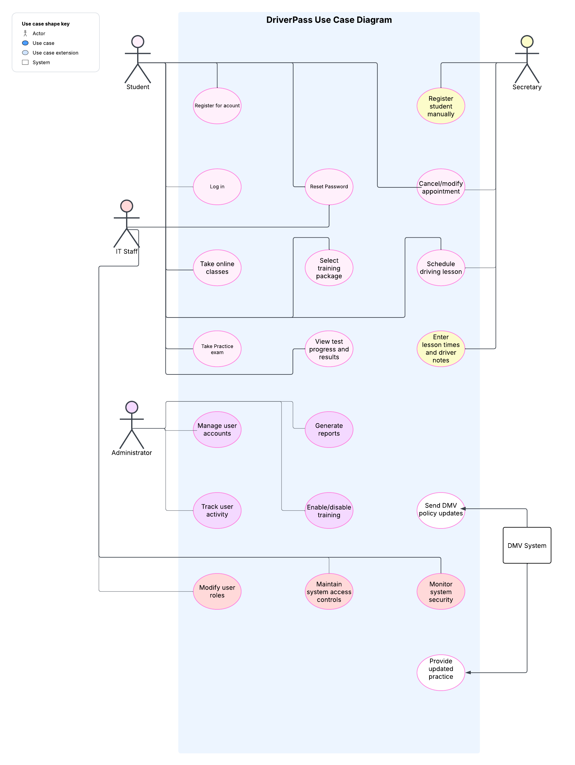

UML Activity Diagrams

### 

### 

### UML Sequence Diagram

### UML Class Diagram

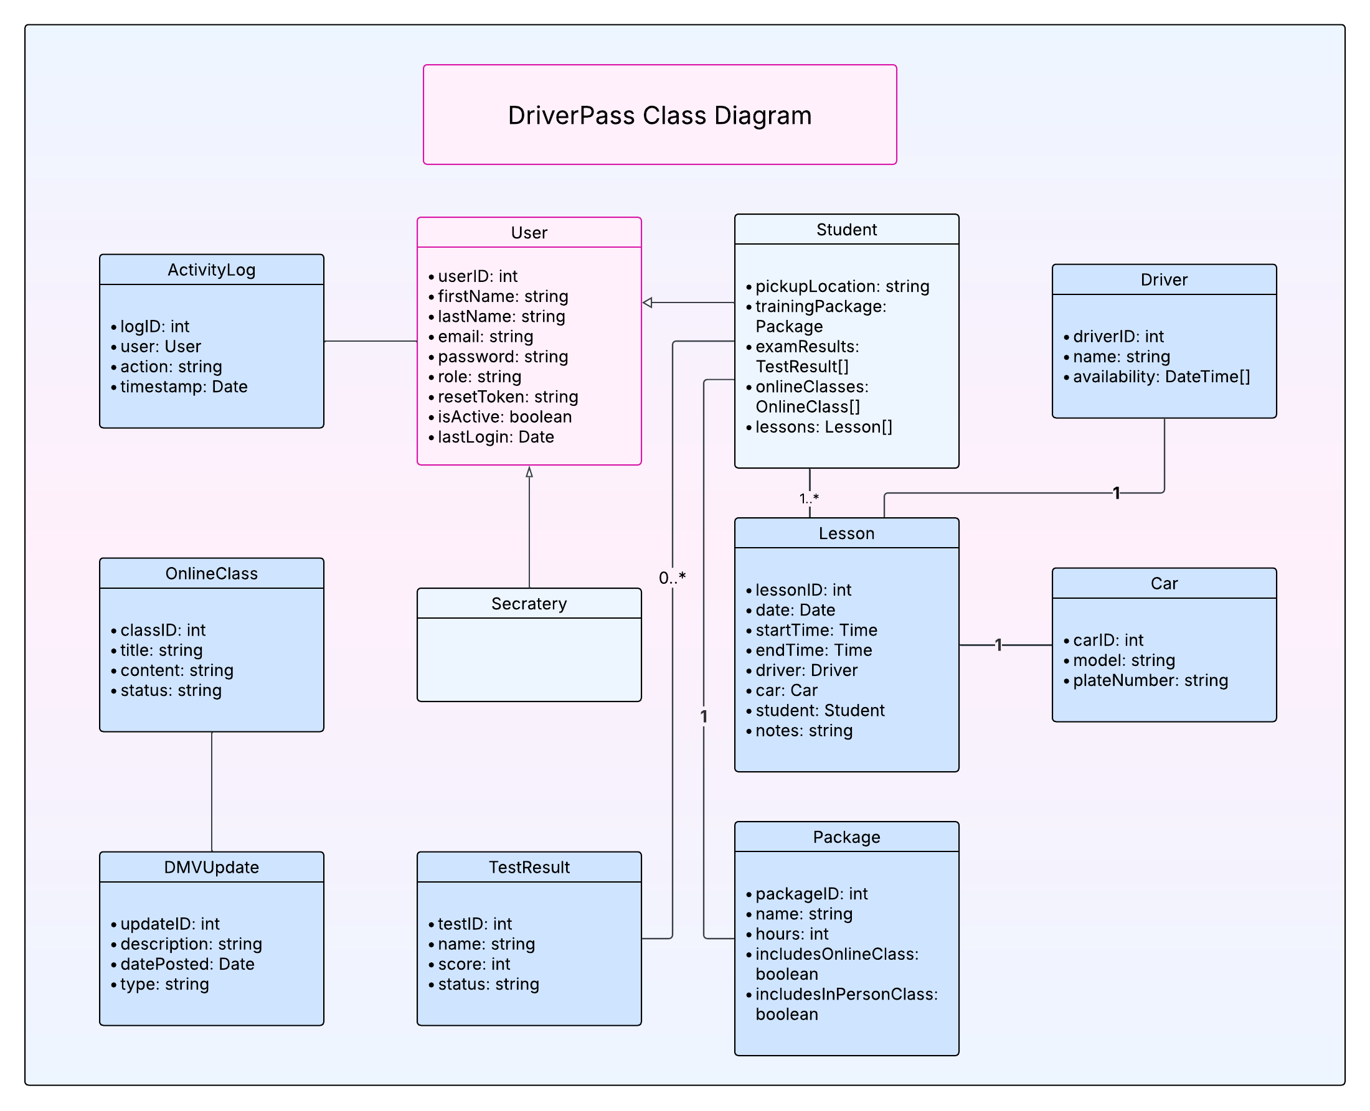

## Technical Requirements

The DriverPass system will run online and needs to be available on both computers and mobile devices. It will be hosted on the cloud so everything stays up-to-date and secure. Here’s what’s needed to make it all work:

**Hardware Needs:**

* Students and staff will need a phone, tablet, or computer with internet access.
* The system itself will run on a cloud server like AWS or Azure.

**Software:**

* The website will use common web tools like HTML, CSS, JavaScript, and possibly something like React for the front end.
* The backend could run on Node.js or Django and will connect to a database like MySQL or PostgreSQL to store all the lesson info, users, and more.

**System Setup:**

* User login and password reset features will be built in, along with different access levels for students, secretaries, admins, and IT.
* Everything will be secured using HTTPS and encrypted where needed.
* There will be tools to track what users do in the system, which helps with troubleshooting or if something goes wrong.
* DMV updates will either be sent in or added by staff to make sure all rules and practice tests stay current.

**Development Tools:**

* We used tools like draw.io or Lucidchart to create diagrams.
* Coding will be done in something like VS Code and stored in GitHub, so everything is backed up and easy to work on as a team.